Ferguson & Civil Rights

a short overview

Prof. Michael Kuelker
October 8, 2014

Civil rights is a term referring to enforceable rights or privileges, which if interfered with by another (whether by the state, by organizations or by private individuals) gives rise to an action for injury.

The most basic civil right is that of life and safety but many other rights flow from this essential condition. Freedom of speech, freedom of the press, and freedom of assembly; the right to vote; freedom from involuntary servitude; and the right to equality in public places – all are examples of civil rights which have legal protection in the U.S. Civil rights are commonly invoked alongside political rights and the right to fair trial and due process under the law.

The Stanford Encyclopedia of Philosophy notes,

In contemporary political thought, the term ‘civil rights’ is indissolubly linked to the struggle for equality of American blacks during the 1950s and 60s. The aim of that struggle was to secure the status of equal citizenship in a liberal democratic state. […]

No contemporary thinker of significance holds that such rights can be legitimately denied to a person on the basis of race, color, sex, religion, national origin, or disability.

Ferguson and Civil Rights Issues

On August 9, 2014, Michael Brown, 18, was gunned down by Officer Darren
Wilson in Ferguson, a municipality of St. Louis, Missouri. The killing sparked an
unusually massive and sustained response, and in the days to come, Michael
Brown and Ferguson MO became synonymous with a new phase of civil rights
activism in America. Days and nights of demonstrations – some of it violent,
much of it not – have captured the national imagination.

It remains to be seen how the case involving Officer Wilson is adjudicated.
What we know without question is that after the incident on Canfield Avenue in
Ferguson, black America said, perhaps more vociferously than at any time in
recent memory years, that it was business as usual no more. The movement is
energized and profoundly shaped by emerging and younger leadership.

Ferguson called attention to complaints of racial profiling and excessive police force and to a context not uncommon in America wherein 94% of Ferguson’s police force is white while 67% of the community is black.

The demonstrations in Ferguson and elsewhere in St. Louis have raised a number of important civil rights issues including free speech, press freedom, the right to assembly. Journalists were harassed, detained and arrested in several instances. Tactics of militarized policing – the riot police and armored vehicles, snipers, tear gas, rubber bullets and stun grenades – drew international attention and became part of a new national discussion about policing. As noted by St. Louis Public Radio on Aug. 14:

Police appear to be violating the First Amendment rights of protesters and journalists in Ferguson by arresting and targeting journalists, and by turning the right to assembly into a daytime-only right, according to legal experts.

‘Police and officials in Ferguson have declared war on the First Amendment,’ said Gregory P. Magarian, a law professor at Washington University Law School. ‘Since Sunday’s police shooting of an unarmed student, Michael Brown, local officials and law enforcement have blatantly violated three core First Amendment principles: our right to engage in peaceful political protest, the importance of open government; and the freedom of the press.’

Magarian added, ‘In the space of one evening, police in Ferguson conducted a master class in destroying the freedom of the press.’

Other legal experts at Washington University and Saint Louis University law schools, as well as a media lawyer, agreed that police actions appear to have violated the First Amendment rights of protesters and journalists. In addition, the American Civil Liberties Union of Eastern Missouri, sent a letter to Ferguson Police Chief Tom Jackson telling him that his crackdowns went ‘far beyond the bounds’ of government authority and that the tactics ‘suppress peaceful expressive activity.’

Among the issues Ferguson is bringing to light is just what form public demonstration in America is allowable under the law. On Oct. 6, 2014, a federal judge ruled that police in Ferguson cannot command peaceful protestors to “keep it moving” otherwise known as the “five second rule.” Police have hitherto commanded demonstrators to stay off the sidewalks and to stay in motion. While acknowledging that police have authority to manage crowds, U.S. District Judge Catherine D. Perry stated that "citizens who wish to gather in the wake of Michael Brown's tragic death have a constitutional right to do so" and that “The practice of requiring peaceful demonstrators and others to walk, rather than stand still, violates the constitution.”

In late September and early October 2014, police response to Ferguson demonstrations took two forms, one soft, one hard. On one hand was the public apology rendered by Ferguson police chief Thomas Jackson. In a videotaped statement released on Sept. 25, Jackson expressed his sorrow to the Brown family directly for the death of Michael Brown and addressed criticisms of how Brown’s body had been handled. Jackson also attempted to walk with protestors, much as Missouri Highway Patrol Capt. Ron Johnson did a week after the killing, a move which brought a layer of calm to the demonstrations.

On the other hand was a clear strategy of police crackdown. Local organizers were targeted for arrest and bonds were set at unusually high levels ($1000, sometimes more) for failure to disperse in a nonviolent demonstration.

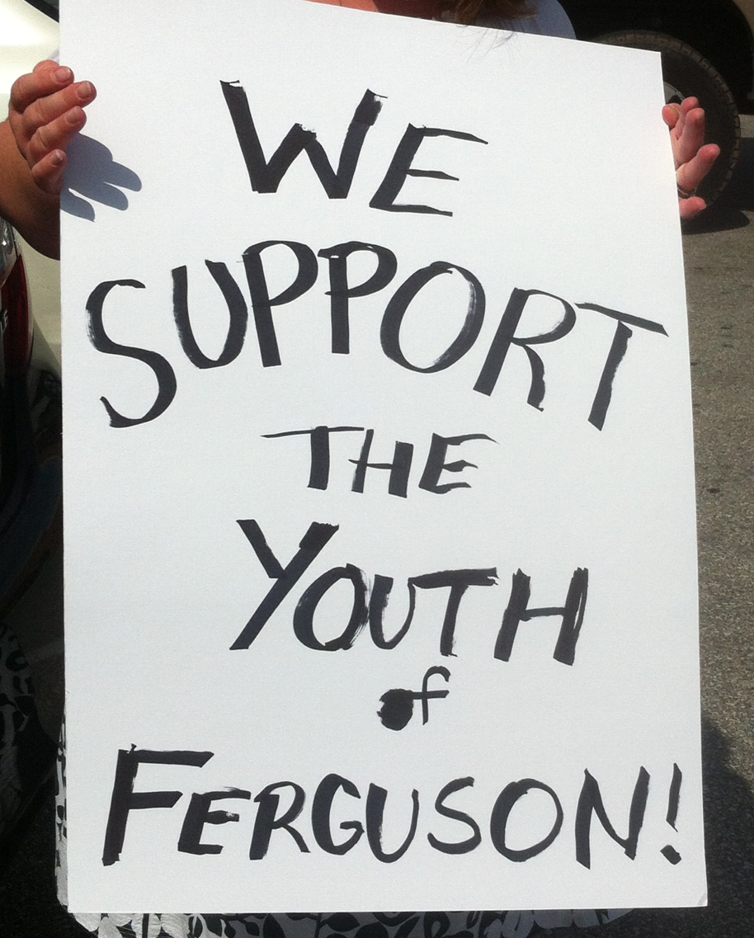

Q: How many police killings are there in America?
A: We don’t know.

The government maintains a database of the officers who are killed in the line of duty. In 2012, it was 48 according to the FBI as cited in a Washington Post article on Sept 8, 2014. But as to the number of people shot or killed by law enforcement every year, no certifiable number exists. The Department of Justice allows U.S. law enforcement agencies to self-report the number of officer-involved shootings in a tally of the FBI’s annual data on “justifiable homicides.”

Comprehensive statistics on officer-involved shootings are also not kept by any of the nation’s leading gun violence and police research groups and think tanks. In fact, prior to the Brown’s shooting, the only person attempting to keep track of the number of police shootings was D. Brian Burghart, the editor and publisher of the 29,000-circulation Reno News & Review, who launched his “Fatal Encounters” project in 2012.
‘Don’t you find it spooky? This is information, this is the government’s job,’ Burghart said. ‘One of the government’s major jobs is to protect us. How can it protect us if it doesn’t know what the best practices are? If it doesn’t know if one local department is killing people at a higher rate than others? When it can’t make decisions based on real numbers to come up with best practices? That to me is an abdication of responsibilities.’

Recent polls suggest that in terms of national reaction, demonstrations are now counter-productive. By continuing them don’t you run the risk of doing more harm than good?

Dr. Martin Luther King Jr.: Again I contend that we are not doing more harm than good in demonstrations because I think demonstrations serve the purpose of bringing the issues out into the open. I have never felt that demonstrations could actually solve the problem. They call attention to the problem, they dramatize the existence of social ills that could be very easily ignored if you did not have demonstrations, and I think the initial reaction to demonstrations is always negative.

Meet the Press – Aug. 21, 1966

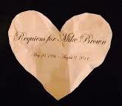

“Requiem for Mike Brown” printed on a paper heart.

On Oct. 4, 2014, demonstrators interrupted a performance by the St. Louis Symphony by singing an old civil rights anthem “Which Side Are You On?” and unfurling banners from the balcony.

The demonstration was met with a few jeers but also a significant amount of applause from members of the orchestra and the audience. Paper hearts such as the one pictured above fluttered from the balcony at Powell Symphony Hall.

These are markedly new and different times as Cornel West and Rev. Osagyefo Sekou note:

The failure of traditional Black leadership to acknowledge the power of youth outrage and organizing, a callous White House, a suspect Justice Department coupled with an out-of-touch Congressional Black Caucus, Ferguson’s electoral apartheid and a national epidemic of police brutality set the stage for the emergence of a new black leadership. Self-organized poor and working class Black youth sit at the center of this new crop of leaders, part of the mass of young folks who took the nation by surprise and demanded justice for Mike Brown.

– “And the Young Ones Shall Lead Them: The Ferguson Rebellion and the Crisis in Black Leadership” [Ebony – Oct. 2, 2014]

New Organizations in St. Louis

#HealSTL

“Turning a moment into a movement. This simple idea is the driving force behind #HealSTL. Our goal is to provide long-term solutions to the complex problems facing St. Louis and other communities across the country.”

Lost Voices

A 10-person-strong political collective who are based at an outdoor encampment in Ferguson. They demonstrate daily at 7 p.m. and, among their varied forms of activism and outreach, the Lost Voices advocate reform of the criminal justice system. See lostvoices.com and #LostVoices14 on Twitter.

Hands Up United

The organization’s goal is
to bring justice to Mike Brown in the short term, and prevent future incidents by building a nation-wide movement to dismantle the New Jim Crow and the prison industrial complex. This means an end to state sponsored violence, including the excessive use of force by law enforcement. It means ending mass incarceration and the criminalization of black and brown people. It means ending racial bias and white supremacy in all its forms. Our dreams are directly linked with those resisting militarism, war, and state repression around the world. We will achieve this new beloved community hand in hand, step by step, in global solidarity with all people committed to lasting peace and full justice.
and its approach is through a youth-led activism to
AMPLIFY: First and foremost, we amplify youth voices, our voices, which are often left out of conversations on social justice.
ENGAGE: We also know that what happened in Ferguson happens all over the country. We aim to spark a national conversation that engages people throughout the country.
TRAIN: To achieve justice, we know that youth need the tools and skills to make real change happen. And so, Hands Up United creates and provides tools, trainings, and leadership at our space in Ferguson that will continue to grow this movement.

Existing Organizations in St. Louis

Organization for Black Struggle

The Organization for Black Struggle defines its mobilization as centered around the following values:
- There is a prevailing need to empower individuals and communities with the knowledge and resources they need to transform the world around them.
- Constant struggle and vigilance is necessary to protect our rights and achieve the justice that we seek
- Our shared oppressions cannot be reduced to the personal; our issues are systemic, so the solutions should be as well:
- While racism can manifest itself personally all too often, racism is also institutionalized and structural. The sooner we can see racism as structural, the sooner we can try to break the cycle.
- Our current economic system degrades people of color and low-income people — justice must address the economic inequality built into the capitalist system
- We believe that movements are based in local struggles; sometimes, like here in Ferguson, our movements find a crack where we must all push together. We are fighting for Justice for Mike Brown, for many others murdered by the police and for people of color as a whole.
Better Family Life

Social services agency which provides job training, educational and social services to underserved county residents. Betterfamilylife.org

Fathers’ Support Center

Organization offering services for men who want to learn to be responsible fathers, committed to a strong family relationship. Fatherssupportcenter.org

MORE - Missourians Organizing for Reform
and Empowerment

Social justice organization formed out of the 99% and Occupy movements now involved in several initiatives including justice for Michael Brown. Organizemo.org/about

